Austin Barrette
Aman Jayswal
Econ 8310: Business Forecasting
05.04.2026
Detecting Baseballs in Training Videos – Semester Project Summary
An Object Detection Approach Using Faster R-CNN
Baseball coaches use video to evaluate hitting mechanics, but reviewing hours of training footage by hand is slow and inconsistent. An automated system that can reliably locate the ball in every frame would let a coach quickly find the moments that matter (the swing, contact, and ball flight) without scrubbing through long stretches of empty footage. The challenge is that baseballs are difficult to detect by computer. They are small relative to the frame, they move fast enough to blur across multiple pixels, and they appear against varied backgrounds including netting, grass, walls, and other equipment. Lighting changes and camera angles add further variation that a model must learn to handle. The goal of this project was to build an object detection model that draws tight bounding boxes around baseballs in short training videos provided by a local coach. Success for this project would involve building a model that detects the ball consistently across frames and produces predicted boxes that closely match the position of the actual ball.
The class collectively annotated 60 short training videos using CVAT, drawing bounding boxes around every visible baseball in each frame. Each annotation also carried a 'moving' attribute marking whether the ball was in motion or stationary. All annotations were exported as XML files and shared across teams through OneDrive. Before training, we audited every annotation file and applied two quality filters. Files with fewer than 10 annotated frames were excluded as likely incomplete, and files with zero moving balls across all frames were excluded as a sign of an annotation issue. We operated off the assumption that every video should include at least one moving ball. We also removed videos that did not have a matching annotation file. After filtering, our final training set consisted of 38 videos that we used for our analysis.
Table 1. Dataset summary after quality filtering
Metric | Value
Videos in training set | 38
Total annotated frames | ~2,450
Total baseball annotations | ~22,500
Train / validation / test split | 70% / 15% / 15%

We split the data into 70 percent for training, 15 percent for validation, and 15 percent for a held-out test set the model never saw during training. The held-out test set is what gives us an honest estimate of how the model would perform on new footage. Following guidance from class, we built our data loader to extract every annotated frame from each video once at startup and store them in memory. Dr. White noted that loading all data upfront is preferable when feasible, even though it would not scale to thousands or millions of videos. With 38 videos and roughly 2,450 annotated frames, this fit comfortably in available RAM and made training significantly faster. The model could pull frames directly from memory during each epoch rather than re-decoding video files for every batch. We acknowledge that this approach would need to be replaced with a streaming or pickled-cache approach for any production deployment with substantially more data.
Following feedback on our proposal, which encouraged us to look carefully at pretrained object detection models available through PyTorch and plan a strategy for aligning our training data with that model, we chose Faster R-CNN. Faster R-CNN is a well-established object detection architecture, and we used transfer learning rather than training from scratch. Specifically, we started from a version of Faster R-CNN pretrained on COCO, a large public dataset of 91 object categories. We kept all the pretrained feature extraction layers (the parts of the network that have already learned what edges, textures, and shapes look like) and replaced only the final classification layer with one that predicts two classes: background and baseball. The data alignment piece of his feedback drove much of our preprocessing work. Every annotated frame is resized to a consistent square dimension, every bounding box is normalized to that frame size, and every annotation is wrapped in the exact dictionary format Faster R-CNN expects. This approach suited our situation well because our dataset, while large enough for fine-tuning, is far too small to train a detector from scratch.
We trained the model for 10 epochs using a standard optimization technique called stochastic gradient descent. The way stochastic gradient descent works is the model makes predictions on a small batch of training images, compares those predictions to the correct answers, and then nudges its internal settings slightly in the direction that would have produced better predictions. Repeated thousands of times across the training set, these small nudges add up to a model that performs well. The size of each nudge is controlled by the learning rate. We chose a learning rate of 0.001, deliberately lower than the value originally suggested for this task. Early experiments by classmates showed that a higher rate of 0.005 caused the model's training to fail entirely as the nudges became too large to be useful. We also used a learning rate scheduler that automatically reduced the size of the nudges by 90 percent every three epochs. This setup lets the model make broad adjustments early in training and finer refinements as it converges. After each training epoch we evaluated the model on the validation set and saved the model whenever validation loss improved, ensuring we kept the best version of the model rather than just the final one.
Based on feedback from assignment 3 earlier in the semester, we followed the recommendation to use Colab's free GPU time instead of training on a local machine. The full 10-epoch run completed in approximately one hour. As a point of comparison, our prior homework assignment trained a similar model on only four videos using a local CPU and took several hours. Running on the GPU with nine times the data and twice the epochs still cut training time to roughly one third. The reason for this difference is that GPUs are designed for the kind of work neural network training requires, which includes thousands of identical mathematical operations performed simultaneously across many small pieces of data. A CPU runs a few complex tasks one at a time, while a GPU runs thousands of simple tasks in parallel, making it ideal for the millions of matrix operations Faster R-CNN performs in every training batch. To stay within the free GPU allotment, we structured the notebook so that data loading, model building, and evaluation each ran in their own cells. This let us re-run only the specific step we needed to without retraining the entire model from scratch.
The model trained successfully on the Colab T4 GPU in approximately one hour, covering 10 epochs across 1,775 training frames. Training and validation loss tracked closely together throughout the run, with no signs of overfitting. The best version of the model occurred at epoch 8 with a validation loss of 0.2281, after which performance plateaued. The training curve shows the expected behavior of fine-tuning a pretrained network:
- Sharp initial drop in the first three epochs
- Clear inflection point at epoch 4 when the learning rate scheduler stepped down
- Gradual convergence through the remaining epochs
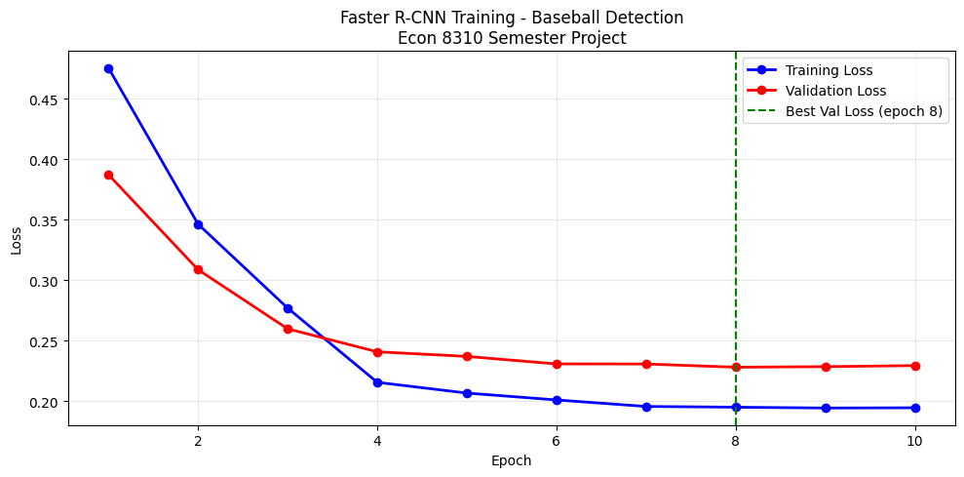

On the held-out test set of 356 frames the model never saw during training, the model achieved strong overall performance. Mean Average Precision at IoU 0.50 (the standard PASCAL VOC threshold) reached 0.83, indicating the model correctly identifies and locates baseballs in the great majority of frames. The stricter COCO-style metric (mAP averaged across IoU thresholds 0.50 to 0.95) was 0.60, and the average Intersection over Union for correctly detected balls was 0.86. This means predicted bounding boxes overlap with the ground truth by 86 percent on average. Precision and recall were both above 82 percent, producing an F1 score of 0.83.

Table 2. Test set performance metrics
Metric | Value | Interpretation
mAP @ IoU=0.50 | 0.83 | Strong
mAP @ IoU=0.50-0.95 | 0.60 | Good
Mean IoU (correct) | 0.86 | Good
Precision | 0.82 | Strong
Recall | 0.84 | Strong
F1 Score | 0.83 | Strong

Breaking down the test results by whether the ball was annotated as moving or stationary reveals an important pattern. Of the 3,278 stationary balls in the test set, the model detected 86 percent. Of the 201 moving balls in the test set, the model detected only 52 percent. This roughly two-to-one gap is consistent with the inherent difficulty of the moving-ball problem. Motion blur stretches the ball across multiple pixels, distorts its circular shape, and frequently places it against confusing background features such as the bat or the swinging batter. It is also consistent with the data we trained on, since only about 6 percent of all annotated boxes in the dataset are moving balls. The model has comparatively few examples to learn the appearance of motion blur from. We view this finding as more informative rather than disqualifying. For a coach using this tool to find swing moments in training footage, missing some heavily blurred ball positions during a pitch is far less costly than missing the stationary balls that mark setup, contact, and rest periods between pitches. That being said, closing the moving-ball gap is the most impactful direction for future improvement, and we discuss specific approaches in the next section.

Several limitations are worth noting. Our 38-video training set comes from a single coach in similar settings, so the model is best suited to footage that resembles what it has seen. Detection performance on dramatically different angles, lighting, or camera positions cannot be guaranteed. We also resized every video frame to 224 by 224 pixels for training, which compresses small baseballs significantly and likely hurts detection of balls that take up only a few pixels in the original frame.
Several improvements would meaningfully strengthen the system. The most direct gain would come from additional training data focused specifically on moving balls under varied conditions, which means different camera angles, indoor and outdoor lighting, and a wider range of pitcher and batter positions. Because moving balls represent only about 6 percent of our current annotations, even a modest additional collection of moving-ball footage would help close the recall gap we observed between moving and stationary detections. Training at a higher input resolution would improve detection of small balls at the cost of longer training time. Finally, post-processing the per-frame predictions with a tracking algorithm could smooth out individual missed detections by enforcing temporal continuity. For example, if the ball was detected in frames 50 and 52, we can be confident it was present in frame 51 even if the model missed it.
This project demonstrates that a publicly available object detection architecture, fine-tuned on a modest amount of carefully cleaned domain-specific data, can be used to detect a small, fast-moving object in real-world video. Our final model achieved a mean Average Precision of 0.83 at the standard IoU threshold, with bounding boxes averaging 86 percent overlap with ground truth on correct detections. The pipeline takes raw video and CVAT annotation files as inputs, applies quality filters to exclude incomplete or low-quality annotations, fine-tunes Faster R-CNN through transfer learning, and produces a saved model that can be reloaded to run inference on new footage without retraining.
The full code, trained model weights, and supporting documentation are available in our GitHub repository:
[GITHUB LINK]
[GOOGLE DRIVE LINK]
(Includes Model output files that were too large to upload to github)

